UNIVERSITY OF THE EAST

Rating
152 Samson Road, Caloocan City
College of Engineering
Information Technology Department

CCS2102 – OBJECT ORIENTED PROGRAMMING
Laboratory Activity 12

Name | Gaspar, Ian Conner Earl B. | Section: | IT2G
Student Number | 20131129607 | Professor: | Celis, J. R. E.

PROBLEM 1:

You are developing a flight reservation system. Create classes for Flight, Pilot, and Passenger. A Flight can have multiple Passengers and two Pilots (Captain and Co-Pilot). You are free to decide what attributes, data types, and access specifiers you will need to complete the program. Implement methods that will allow 1) passengers to be assigned to a flight, 2) assign a captain and co-pilot to a flight, 3) list the passengers assigned to a flight, and 4) list the captain and co-pilot assigned to a flight.

- Draw the Class Diagram.
- Implement the diagram in a C++ program.
  - Provide the code of the program
  - Provide a sample output of the program

PROBLEM 2:

Create a system that represents the relationships between computer components. A Computer is composed of a CPU, Memory, and Storage. Create a class for each. You are free to decide what attributes, data types, and access specifiers you will need to complete the program. Implement a method that will allow the Computer class to be assigned a CPU, Memory, and Storage. Implement a method that will list the CPU, Memory, and RAM assigned to a computer.

- Draw the Class Diagram.
- Implement the diagram in a C++ program.
  - Provide the code of the program
  - Provide a sample output of the program

------------------------------------------------------------------------------- End of Questions ----------------------------------------------------------------------------

Problem 1
Input:
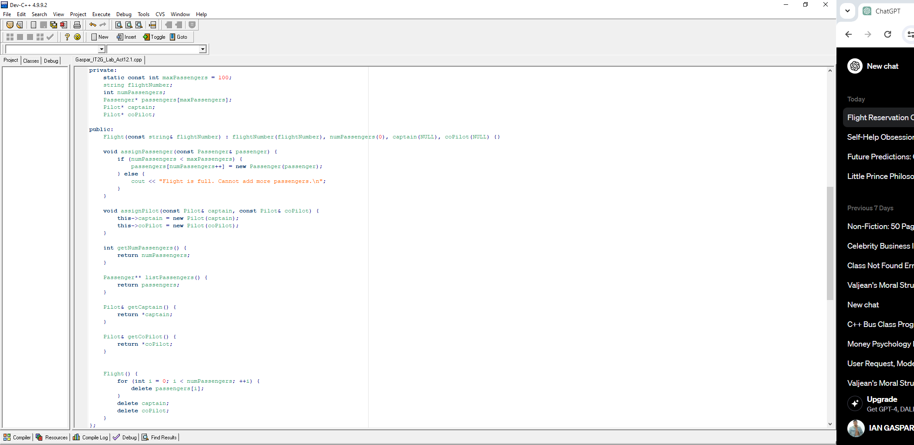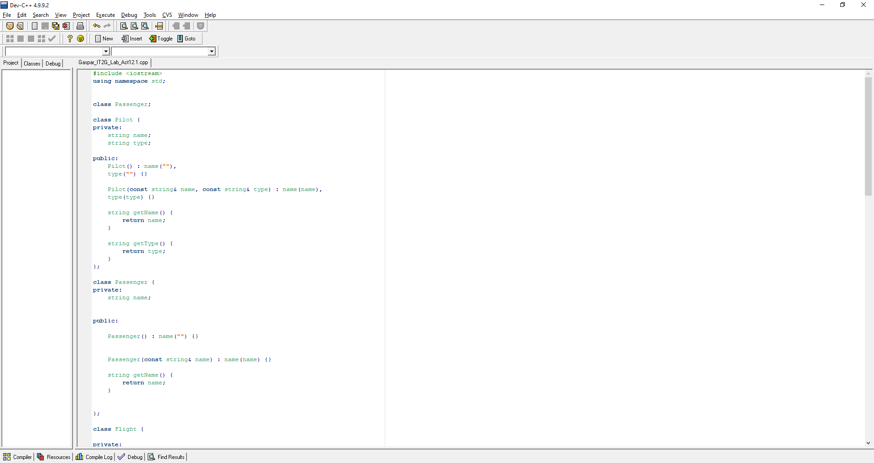
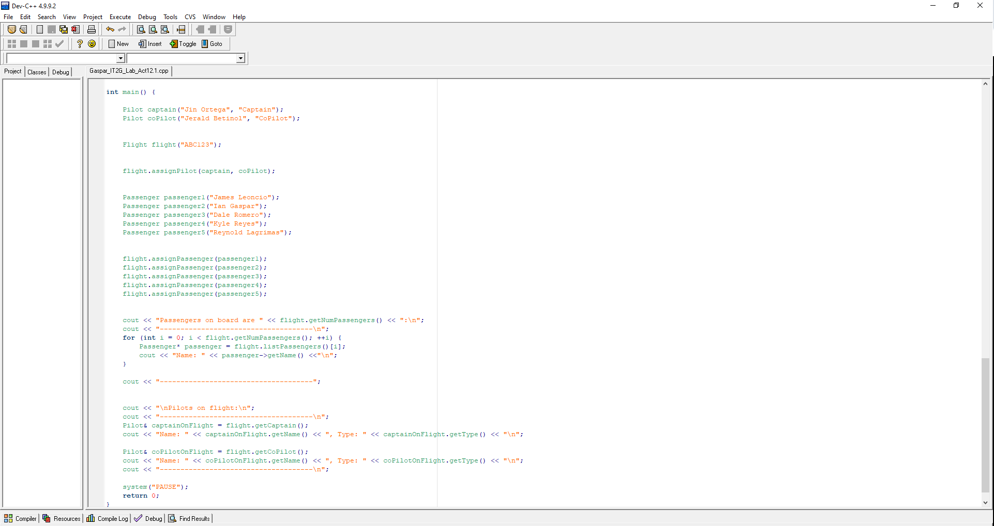
Output:
